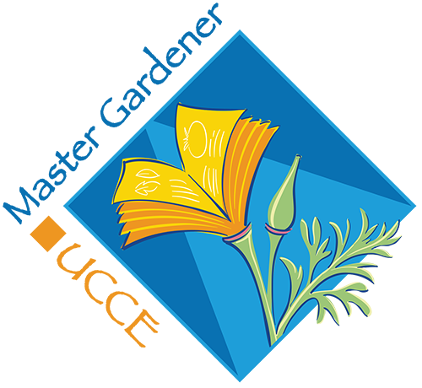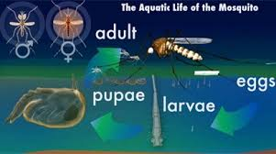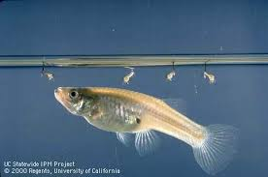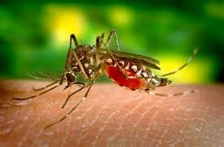

[SDVector.com](http://sdvector.com/), [Vector@sdcounty.ca.gov](mailto:Vector@sdcounty.ca.gov)  858-694-2888

**FIGHT MOSQUITOS--- Remove all standing water in your garden. It only takes days for the mosquito life cycle to thrive. If you have a pond, you can get free mosquito fish at many locations in San Diego County.**

MOSQUITO FISH

Mosquito-eating fish can be an important control agent for immature mosquitoes. People worldwide have used the mosquito fish, *Gambusia affinis*, for mosquito control. These fish are most effective in man-made bodies of water that don’t connect with natural waters and don’t contain dense stands of emergent vegetation. You can obtain mosquito fish from most vector control districts.

You never should release mosquito fish into streams, ponds, and lakes, because these fish aren’t native to California. Fish native to California are being considered for use as mosquito control agents in habitats where mosquito fish no longer can be released. Your local vector control district is a good source of additional information for mosquito fish alternatives.

### [Day]

[Date]

## Aenean a magna vel pede vestibulum rhoncus. Nulla cursus orci quis tortor.